Part 4 — Functional test results

TC01 — Scholar Registration TC02 — Scholar/Staff Login

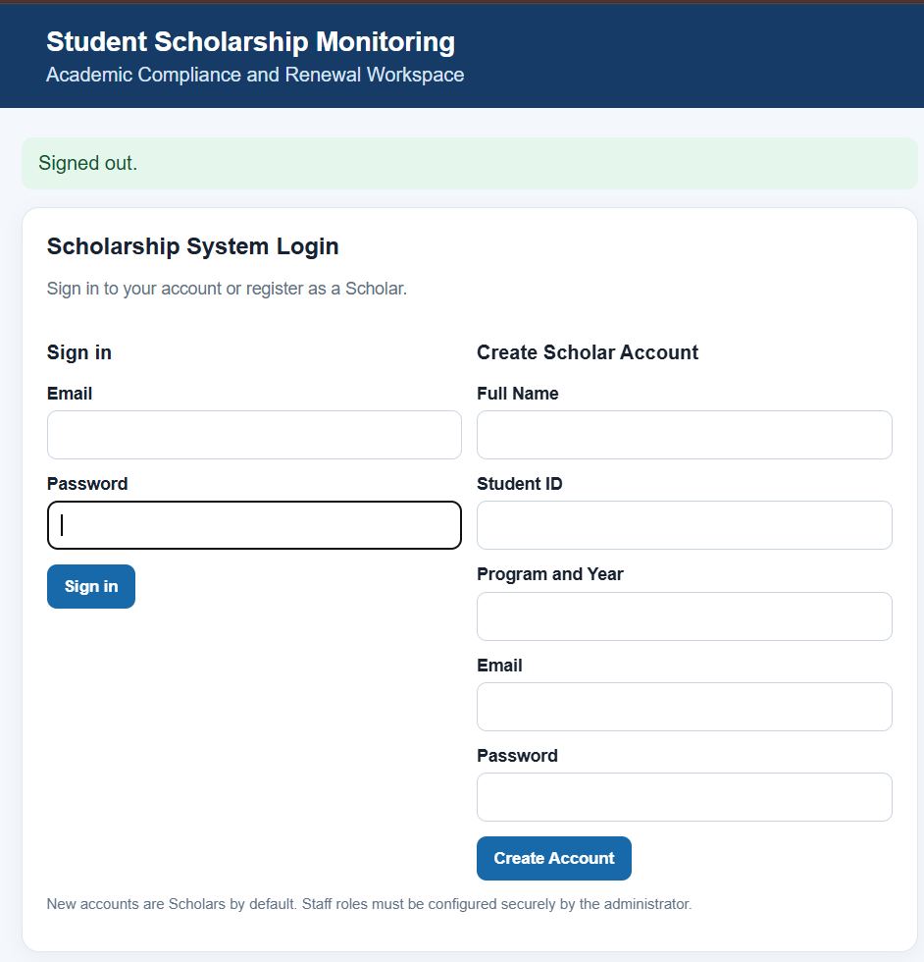
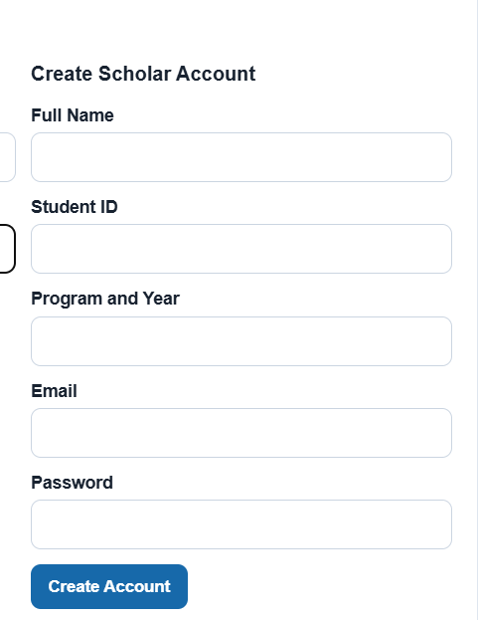

TC03 — Scholar Dashboard
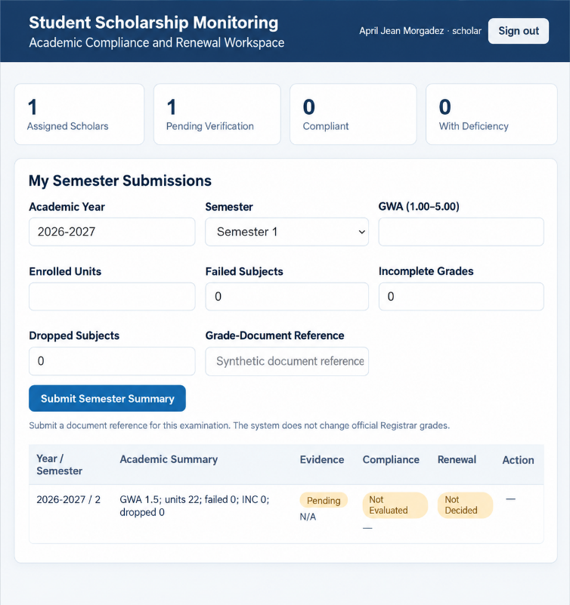

TC04 — Submit Academic Requirements
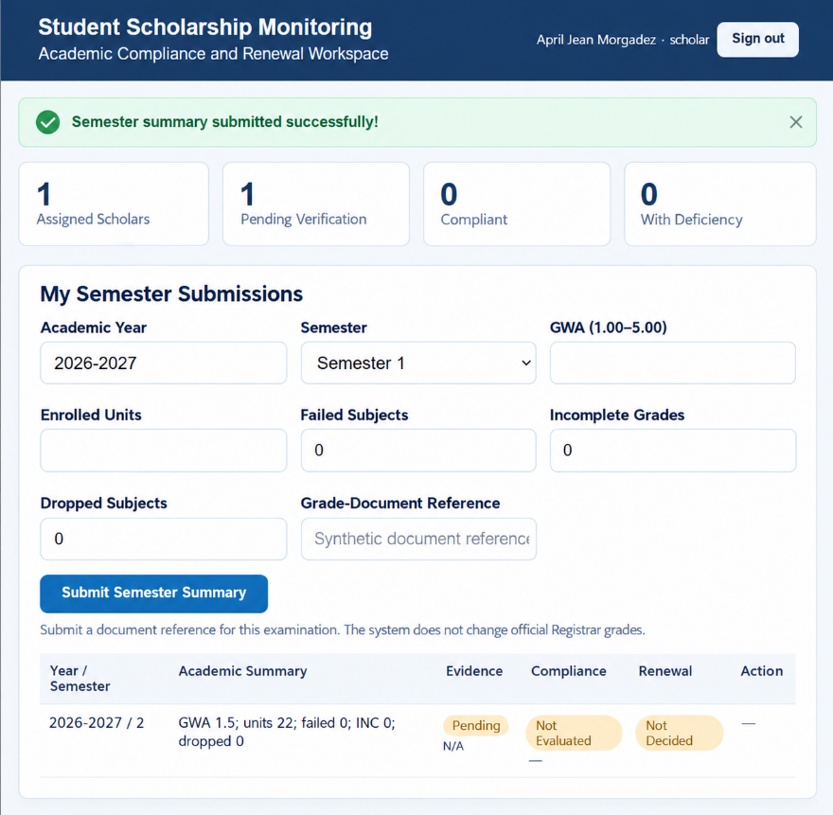

TC05 — Staff Dashboard
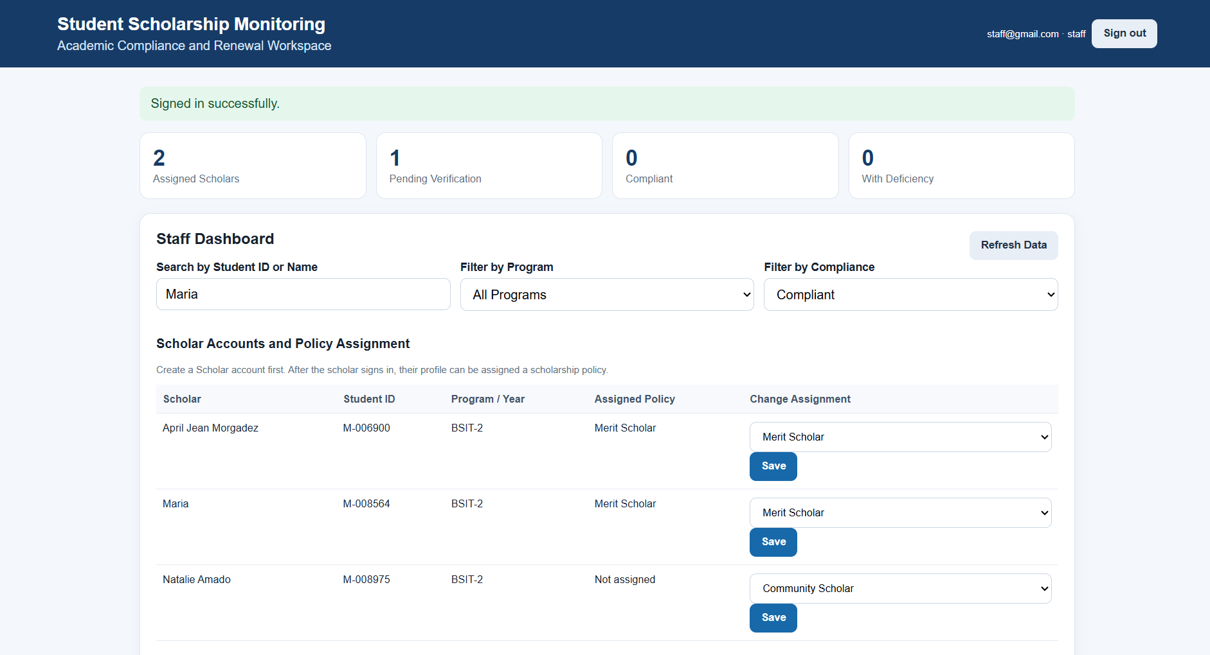

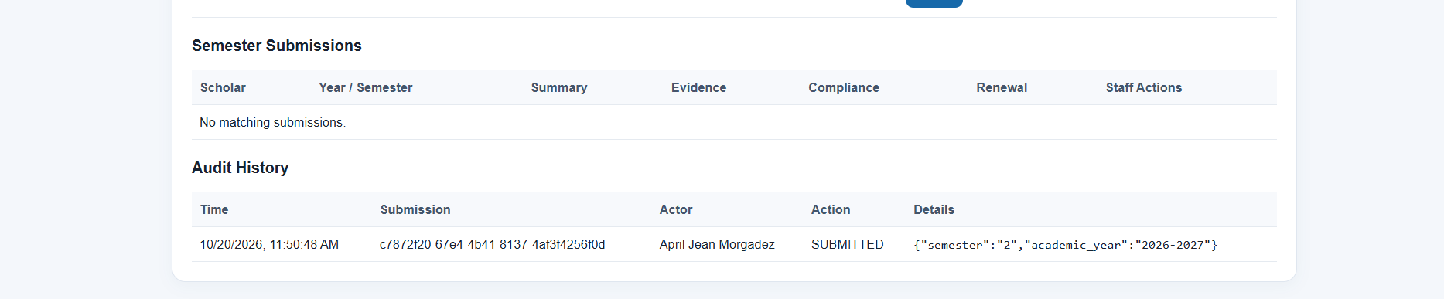

TC06 — Verify or Return Evidence
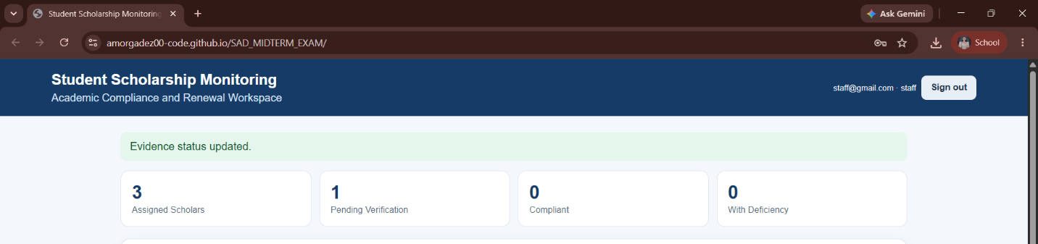

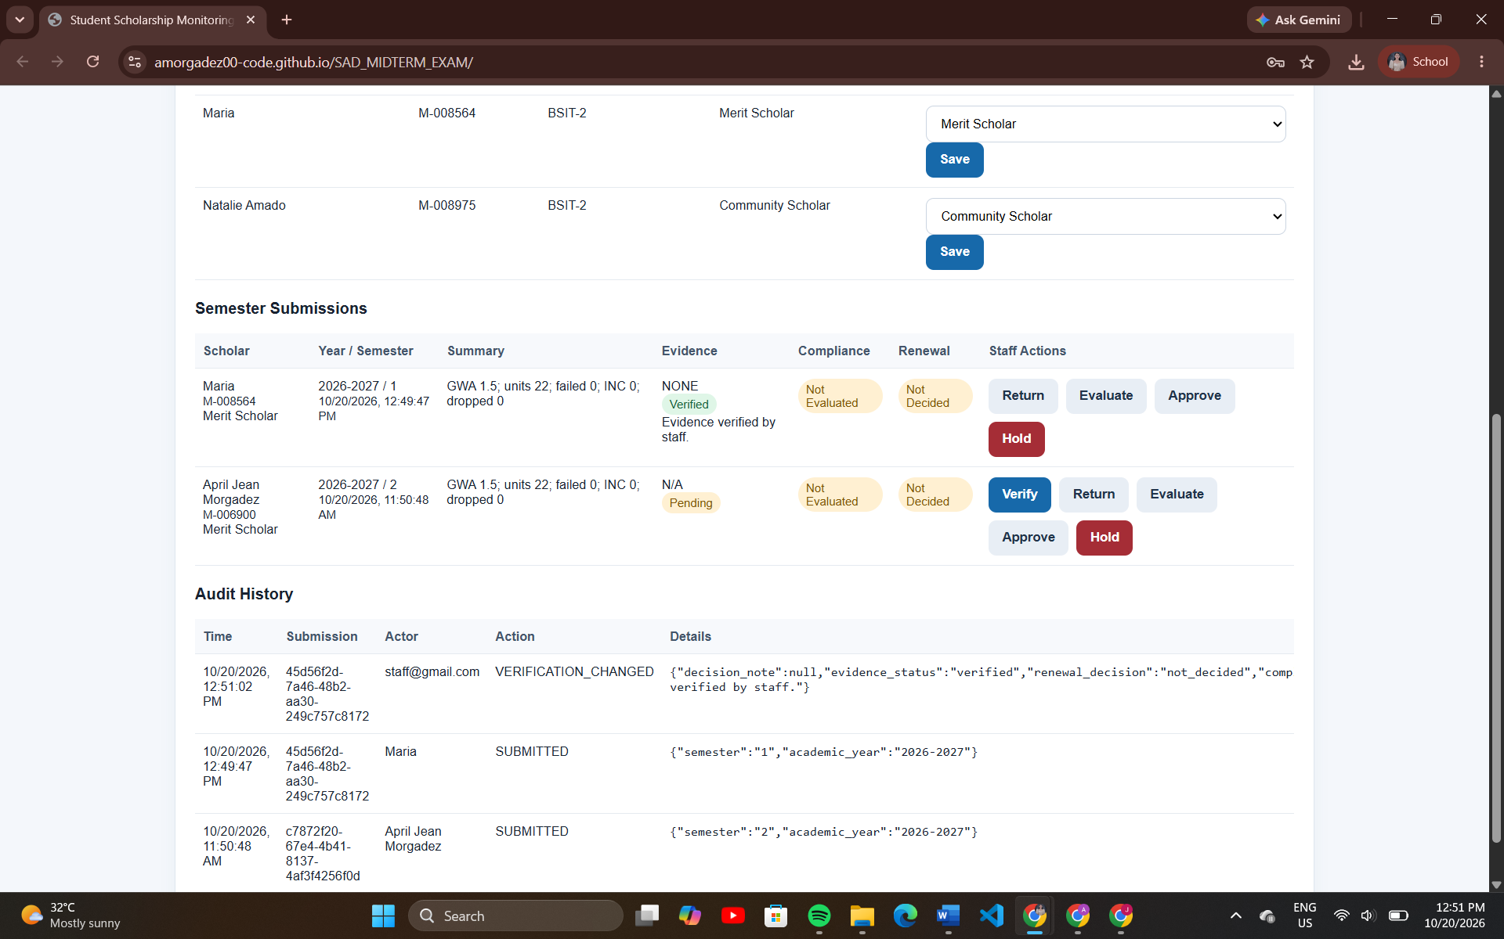

TC07 — Compliance Evaluation
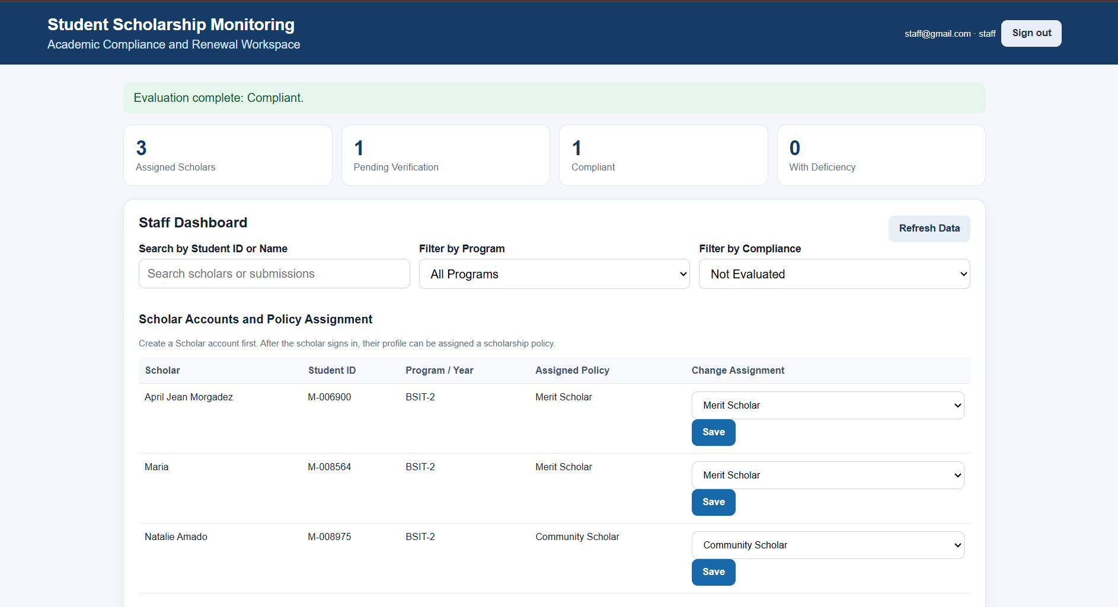

TC08 — Renewal Decision
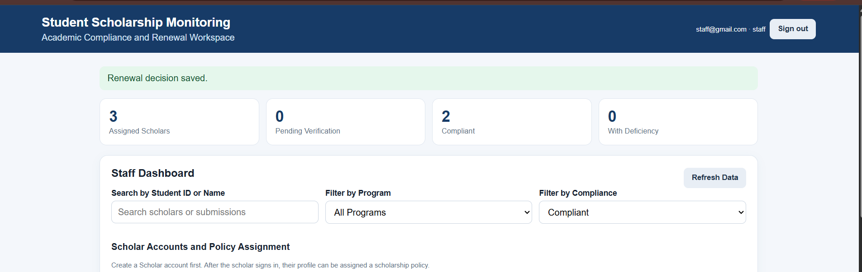

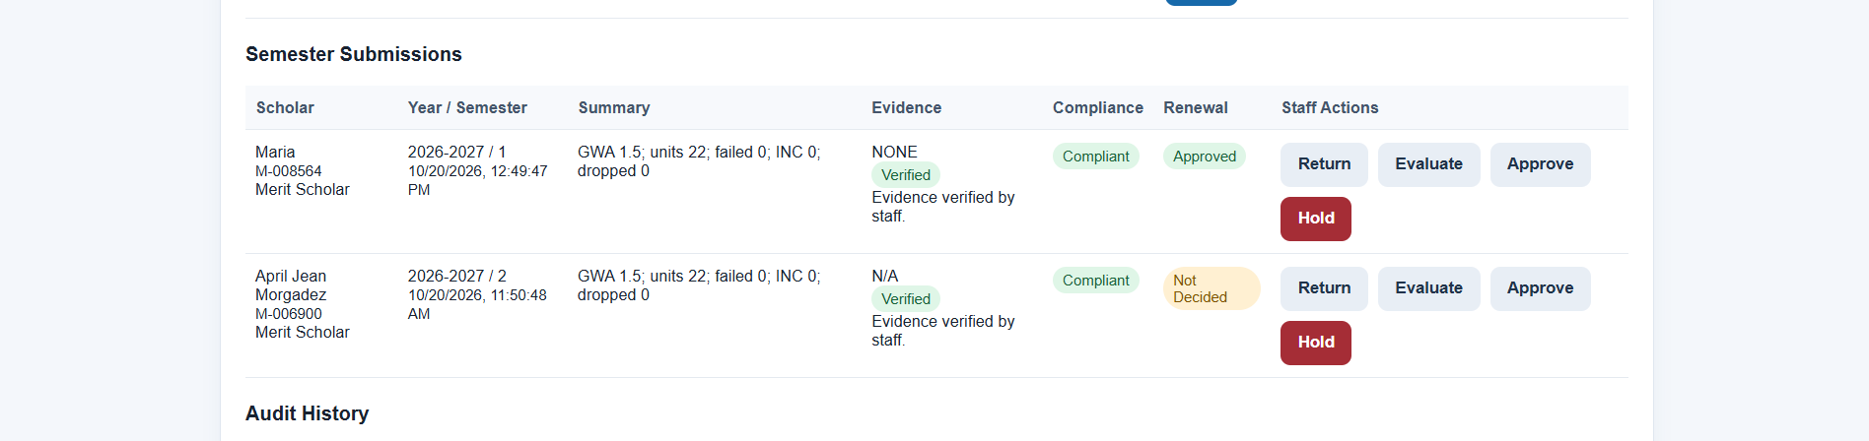

TC09 — Search and Filter
